1. What’s wrong with Python lists (arrays) for some tasks?
- They store items in continuous memory.
- Inserting/deleting in the middle → shift all later elements → slow O(n)O(n).
- Fixed size in low-level languages (but Python lists auto-resize, still costly).
2. Linked list solves that differently
A linked list is a chain of nodes.
- Each node contains:
  - Data (e.g., 10, 20, “apple”)
  - Pointer / reference to the next node (and sometimes previous node).
- Nodes are scattered in memory; no need for continuous space.
Visualize:
text
[10 | *] --> [20 | *] --> [30 | None]
* means address of next node. Last node points to None.
3. Types you’ll encounter
- Singly linked list – one-way (next pointer only).
- Doubly linked list – next + previous pointers (can go backward).
- Circular linked list – last node points back to head.
4. Why use a linked list?
Operation | Array (Python list) | Linked list (singly)
Access by index | O(1)O(1) fast | O(n)O(n) slow (must walk)
Insert at head | O(n)O(n) shifts | O(1)O(1) just change pointers
Insert at tail | O(1)O(1) amortized | O(n)O(n) unless tail pointer kept
Delete an element | O(n)O(n) shifts | O(n)O(n) to find + O(1)O(1) to remove
Key trade-off:
- Linked list = fast insert/delete at ends or known positions, but slow random access.
- Arrays = fast random access, slow insert/delete in middle.
5. Basic operations you must understand
Let’s define a node in Python:
python
class Node:
def __init__(self, data):
self.data = data
self.next = None
Creating a simple list:
python
head = Node(10)
head.next = Node(20)
head.next.next = Node(30)
Traversal (walk through all nodes):
python
current = head
while current:
print(current.data)
current = current.next
Insert at beginning:
python
new_node = Node(5)
new_node.next = head
head = new_node
Delete a node by value (simplified):
python
if head.data == target:
head = head.next
else:
current = head
while current.next and current.next.data != target:
current = current.next
if current.next:
current.next = current.next.next
6. Common beginner confusion
- You cannot jump to index 5 like an array. Must start from head and count.
- If you lose the head, you lose the entire list (garbage).
- In Python, “pointers” are just references – you don’t manage memory manually.
7. Where are linked lists actually used?
- Implementing queues & stacks (efficient push/pop at ends).
- Hash tables (chaining collision resolution).
- Undo functionality (doubly linked list).
- Music playlist (next/previous song).
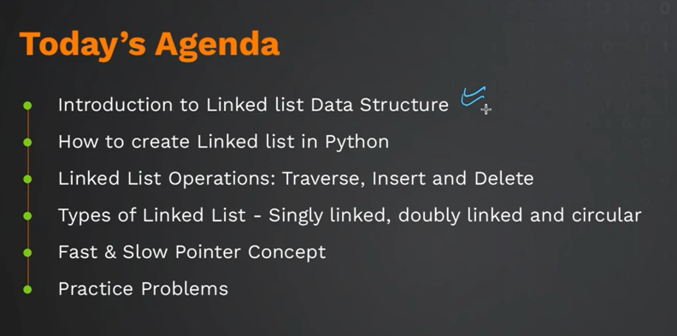
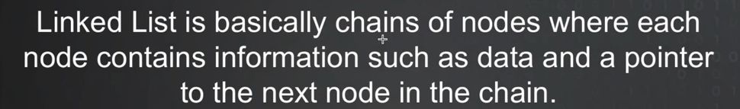

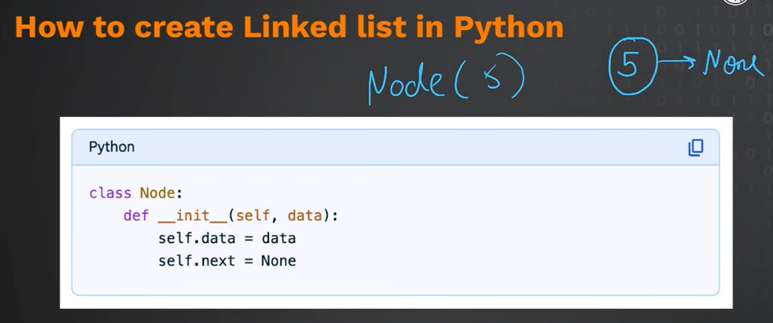

Python-specific note for DSA
Python doesn't have "pointers" but object references work exactly like pointers behind the scenes. When you write self.next = new_node, you're storing a reference (address) to another Node object — that's your link.

Instance Methods (most common)
What they are: Functions that operate on a specific instance of a class. They receive self (the instance) automatically.
Purpose: Read or modify instance-specific data. Each object has its own copy of data, and instance methods work on that copy.
Example:
python
class Node:
def __init__(self, data):
self.data = data # instance variable
def set_data(self, new_data): # instance method
self.data = new_data

n = Node(10)
n.set_data(20) # Python passes n as self automatically
In C++: All non-static member functions are instance methods. The this pointer is implicit (not a parameter). Example:
cpp
class Node {
int data;
public:
void setData(int newData) { data = newData; } // this->data = newData
};
Class Methods
What they are: Functions that operate on the class itself, not an instance. They receive cls (the class) automatically. Decorated with @classmethod.
Purpose: For factory methods (alternative constructors), or for operations that affect all instances (like keeping a count of total objects created).
Example:
python
class Student:
total_students = 0 # class variable
def __init__(self, name):
self.name = name
Student.total_students += 1
@classmethod
def from_string(cls, info_str): # class method
name = info_str.split(",")[0]
return cls(name) # creates instance
@classmethod
def get_total(cls):
return cls.total_students

s1 = Student("Alice")
s2 = Student.from_string("Bob,20") # factory method
print(Student.get_total()) # 2
In C++: Static member functions. Example:
cpp
class Student {
static int total_students;
public:
static int getTotal() { return total_students; } // no this pointer
};
Static Methods
What they are: Normal functions that happen to live inside a class for organization. They receive neither self nor cls. Decorated with @staticmethod.
Purpose: Utility functions logically related to the class but don't need access to instance or class data. Examples: validation, conversions, helper calculations.
Example:
python
class MathUtils:
@staticmethod
def is_even(number):
return number % 2 == 0

print(MathUtils.is_even(5)) # False (called on class, no instance needed)
In C++: Also static member functions — but C++ makes no distinction between class methods and static methods. In C++, both are just static functions. Python separates them because class methods receive the class (allowing inheritance-friendly factory methods), while static methods receive nothing.
Key Differences (Python specific)
Feature | Instance Method | Class Method | Static Method
First parameter | self (instance) | cls (class) | none
Can access instance data? | Yes | No (unless you create or pass one) | No
Can access/modify class data? | Yes (via self.__class__) | Yes | Yes (if you explicitly name the class)
Called on instance? | obj.method() | Class.method() or obj.method() | same as class method
Decorator needed? | No | @classmethod | @staticmethod
Inheritance behavior | Overridden normally | Receives subclass as cls | No special inheritance behavior
Simple Rule for Beginners
- Need to read/write self.xxx? Use instance method.
- Need alternative constructor or want to track all objects? Use class method.
- Just a helper that doesn't touch self or cls? Use static method (or even a normal function outside class).
For DSA with linked lists, you will almost exclusively use instance methods (append, delete, search, reverse) because they operate on a specific linked list object. Class methods are rare in basic DSA; static methods occasionally for utilities like Node.validate_data(value).

You're thinking of self and cls as holders for what gets passed automatically. Let me clarify with an analogy to C++ (since you know it).
What self really is
self is the object instance — the specific chunk of memory holding that object's data. When you call obj.method(arg), Python passes obj as self to the method.
It is not a variable that stores the argument. It is the object. The arguments (like data) are separate.
Example:
python
first = Node(10) # Python: new object created, then __init__(that_object, 10)
Inside __init__, self refers to first (the object). Then self.data = data attaches a new attribute to that object.
What cls is
cls is the class itself — the blueprint, not any instance. When you call Car.from_string(...), Python passes the Car class as cls.
So cls is like self but for the class level. In C++ terms, cls is like a static context where you have access to static members and can create instances (like a factory).
What does cls do in practice?
Inside @classmethod:
- cls refers to the class (e.g., Car).
- You can access class variables (cls.total_cars).
- You can call the class constructor: cls(...) creates a new instance (just like Car(...)).
- If a subclass inherits this method, cls will be the subclass, not the parent. That's the key benefit over using the class name directly.
Difference between self and cls in your mental model
Aspect | self | cls
What it refers to | An instance (one object) | The class (type)
Can access instance variables? | Yes (self.name) | No
Can access class variables? | Yes (via self.__class__ or directly) | Yes (cls.class_var)
Can create new instances? | Not directly (except self.__class__()) | Yes (cls())
Passed automatically when? | Calling method on instance | Calling method on class
Your statement corrected
You said: "self creates a variable in a function and stores the value taken from parameter"
That's not correct. self is given to you by Python. It already exists (the object). You don't store parameters into self; you store them into attributes of self (self.data = data). Parameters like data are stored separately.
Similarly, cls is also given to you — it's the class. You don't create it.

The head node is simply the first node in a linked list. It’s the entry point to the entire list.
Significance:
- If you lose the head, you lose the whole list (because you can’t reach any other node without starting at the head).
- Every operation (traversal, search, insertion, deletion) begins at the head.
- An empty linked list has head = None (or null).
Example in code:
python
class LinkedList:
def __init__(self):
self.head = None # initially empty
Why it matters:
- To traverse: start with current = self.head and move to current.next.
- To insert at beginning: new node’s next becomes current head, then update head to new node.
- To delete first node: just set self.head = self.head.next.
Without a head, you have no way to access the list. That’s why every linked list implementation stores a reference to the head.

The main benefits of a linked list over a simple array (or Python list) are:
1. Dynamic size without resizing cost
- Array has fixed size (in low-level languages) or resizing requires copying all elements (O(n)).
- Linked list grows one node at a time, no resizing overhead.
2. Fast insertions/deletions at the beginning
- Array: inserting at index 0 shifts all elements → O(n).
- Linked list: update head pointer → O(1).
3. Fast insertions/deletions anywhere (if you already have the node)
- Array: shifting elements O(n).
- Linked list: just change a few pointers O(1) (once you’re at the position).
4. No wasted contiguous memory
- Array needs a single block of free memory.
- Linked list nodes can be scattered anywhere; uses memory more flexibly.
5. Efficient for large, frequent insert/delete operations
- When data size changes often, linked list avoids shifting cost.
Downside (so you’re not misled):
- Slow random access (no indexing) → O(n) to find nth element.
- Extra memory for pointer storage (next reference).
- Worse cache locality (nodes spread in memory).
In short: use arrays when you need fast access by index. Use linked lists when you need frequent insert/delete at ends or middle, and you rarely search by position.

Linked list operations:
Traversal, insertion, Deletion, Searching, Updating, Reversal

The main types of linked lists are:

1. Singly Linked List
- Each node contains data and a next pointer (to the next node).
- Traversal is forward-only.
- Example: head → [10 | next] → [20 | next] → [30 | next] → None

2. Doubly Linked List
- Each node contains data, a next pointer, and a prev pointer (to the previous node).
- Allows forward and backward traversal.
- Example: None ← [10 | prev,next] ↔ [20 | prev,next] ↔ [30 | prev,next] → None

3. Circular Linked List
- The last node points back to the first node (instead of None).
- Can be singly circular or doubly circular.
- Useful for round-robin scheduling, game loops, etc.
- Example (singly circular): head → [10] → [20] → [30] → [10] (back to head)

The fast and slow pointer technique is a common algorithm pattern used in linked list problems where two pointers traverse the list at different speeds.
The slow pointer moves one step at a time (slow = slow.next). The fast pointer moves two steps at a time (fast = fast.next.next).
This technique is useful for several problems:
Finding the middle node of a linked list – When the fast pointer reaches the end, the slow pointer is at the middle.
Detecting a cycle – If there is a cycle, the fast pointer will eventually catch up to the slow pointer from behind. If fast reaches None, no cycle exists.
Finding the start of a cycle – After detecting a cycle, resetting one pointer to head and moving both one step each time makes them meet at the cycle's start node.
Removing the nth node from the end – Move fast n steps ahead, then move both until fast reaches the end; slow will be just before the target node.
The main advantage is that it solves these problems in O(n) time with O(1) extra space.

